Sequence Diagram Exercises

Exercise 1

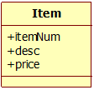

Scenario: Update Item Price

Precondition:

Item information for one item is being displayed on the screen; the system is in update mode.

|  |  |
| --- | --- |
| Actor (manager) | System |
| Enters a new price and requests to change price. | Sets the new price and displays the new price and item |

Exercise 2

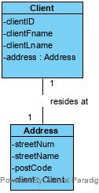

Scenario: Get Client Postal Code

Precondition:

A list of client id’s and names is displayed. All clients and their addresses have been retrieved from the database.

|  |  |
| --- | --- |
| Actor (Manager) | System |
| Selects a client. | The system displays the postal code of the client address. |

Assume that Client has already been retrieved.

Exercise 3

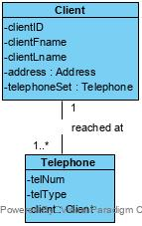

Scenario: Get Client telephone numbers

Precondition:

A list of client id’s and names is displayed. All clients have been retrieved from the database.

|  |  |
| --- | --- |
| Actor (Manager) | System |
| Selects a client. | The system displays a list of telephone numbers including the telephone number and the type of number (example: cell, home, work) |

Assume that Client has already been retrieved.